Survival Week
July 10-14, 2017
Dear Survival Week Camper,
Ever wonder what you would do if you were stranded in the middle of the woods and forced to survive on your wits? How would you eat, drink, sleep, stay warm and dry? This week, you’ll work on skills needed to handle these and other situations. Throughout the week, we’ll find edible and medicinal plants. We’ll go to Rocks State Park to practice building shelters and making fire. For a real challenge by choice, try to conquer Guppy Gulch Water Park with the blob, cliff jump, zip line and inflatable stunts! We culminate with an overnight campout in Harper’s Ferry, WV, where we’ll hike to an overlook, tube down the Potomac, take a ghost tour, cook in a campfire, take a night-hike and more. Can you survive? Keep scrolling down to see our itinerary.
Registration fee: $475 (aftercare available for an extra $50 fee)

**Parents are welcome to attend any day paying any fees that may be required. Parents, if you plan to come to the overnight trip, let me know two weeks ahead, and be prepared to pay $50 for a background check. You won’t be permitted to attend without the background check. You will be charged for admission costs anywhere we go that day and for the overnight, $55.00 for food, ghost tour, tubing and hostel fees.
There are a few things you need to bring to camp every day, when you come at 8:30. They are listed below:
- A day pack (like a school book bag)
- A bagged lunch
- At least 1 liter of water
- A plastic bag of dry clothes (just in case you want to change)
- A towel
- Closed-toed shoes for water (old tennis shoes work best.)
- Sunscreen and bug repellant
- A hat
- Optional binoculars
Look at the chart below for a list of activities, and special daily items to pack in addition to the ones listed above.
Every day, we are dropped off and picked up at the Emmorton Rec Center. Someone will be there from 8:00a.m., but program begins at 8:30. From there, we will take a bus to the following destinations. Aftercare is available from 3:30 – 6:00 p.m. for an additional $50/week.

Day | Activity | Location | What to bring
Monday  7/10/17  8:30-3:30 | Edible and medicinal plants, fire-building  (Paddle-bording, kayking for a fee) | Hammerman Beach, Gunpowder State Park | Everyday list, beach stuff, money for optional activities
Tuesday  7/11/17  8:30- 3:30 | Deer Creek fun time, shelters, fire, edible plants, stream explore, King and Queen Seat | Rock State Park  Pull-off on Rte 24 just past Rocks Chrome Rd. | everyday list, comfortable walking shoes and wet shoes, snorkel and mask
Wednesday  7/12/17  8:30- 3:30 | Water park (Blob, lily pads, trampoline, 19- foot tall mountain, cliff jump, zip lines… | Guppy Gulch | Sunscreen, bravery for the BLOB, beach stuff, money for snack bar
Thursday  7/13/17  8:30, overnight to … | Tube the Potomac River, dinner at Hostel, hike into town for Harpers Ferry Ghost Tour, night hike, s’mores... | Meet bus at Emmorton Rec. Center and drive to Harpers FerryHostel  19123 Sandy Hook Road, Knoxville, Maryland 21758  (301) 834-7652 | See packing list for Harpers Ferry Overnight (below)
Friday  7/14/17  3:30 (pick-up) | Hike the Maryland Heights Trail and do the historic town of Harpers Ferry. | We’ll return to the rec. center by 3:30 for pick-up. | Stamina and some money for ice cream!
Overnight packing list
Packed Lunch for Thurs.
Comfortable hiking shoes
Water shoes for the river
Bathing suit w/ plastic bag for storage
Sunscreen
Hat, sun glasses
3-4 pairs of socks (not no-show socks)
Clothes to change into Fri. in its own bag
Sleeping bag/pillow
Toiletries and towel
Day Pack (to carry separate from clothes bag)
2 refillable water bottles
Flash light
Rain jacket
Cards or similar non-electronic games/ balls
Money for Harpers Ferry ($20 is sufficient)
Snacks
Binoculars and/or camera

Don’t bring electronics, knives or lighters

Register Now!

Scroll down for pictures.
Photo Gallery
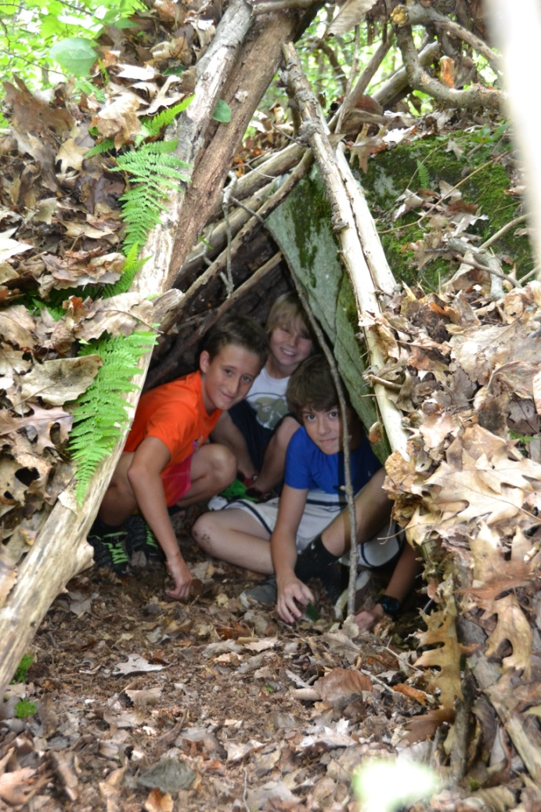

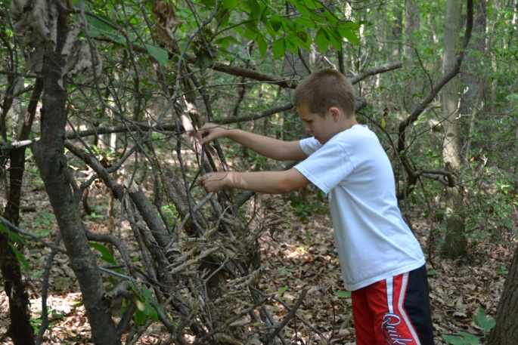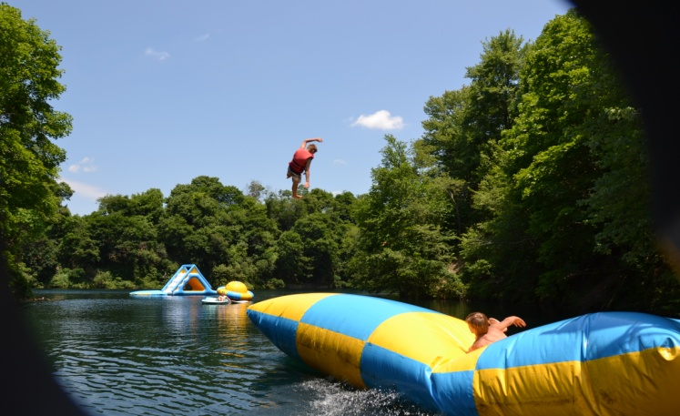
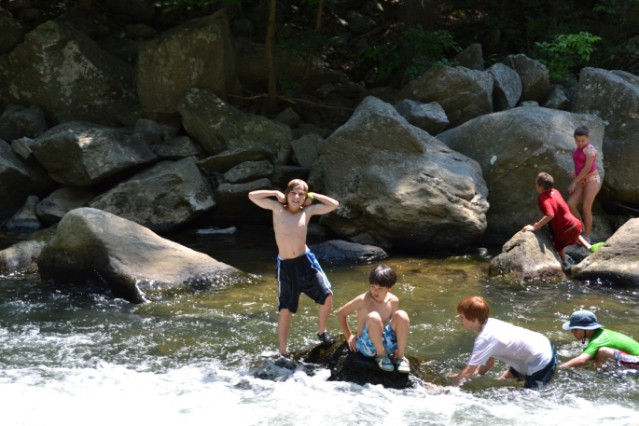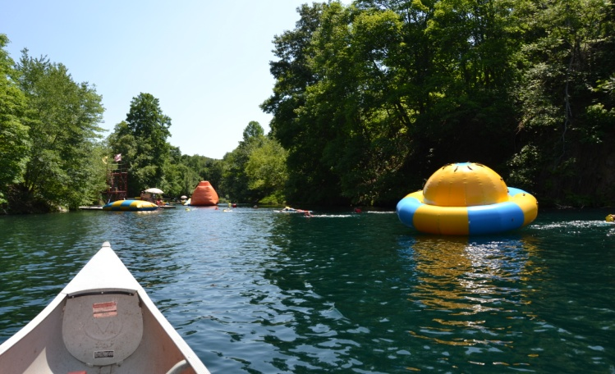
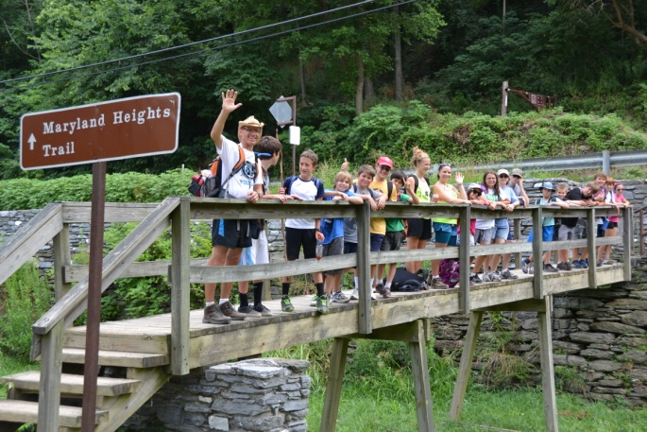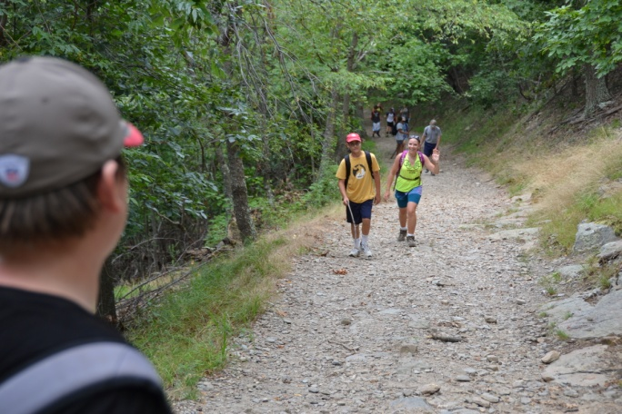
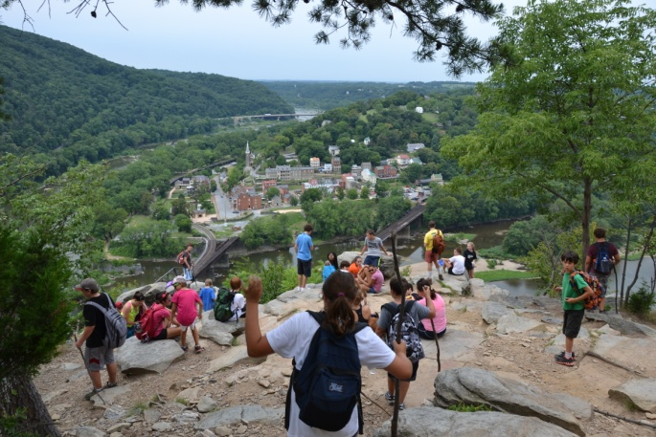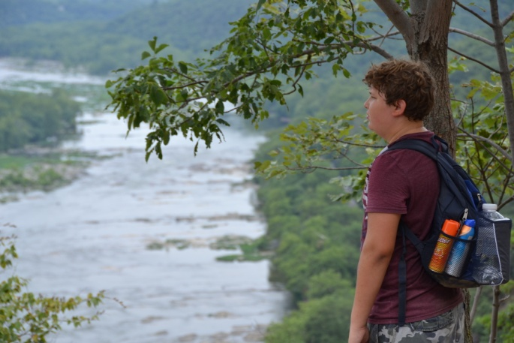
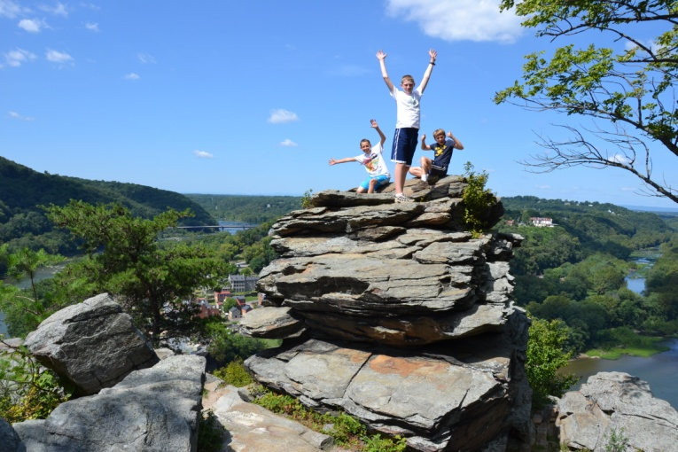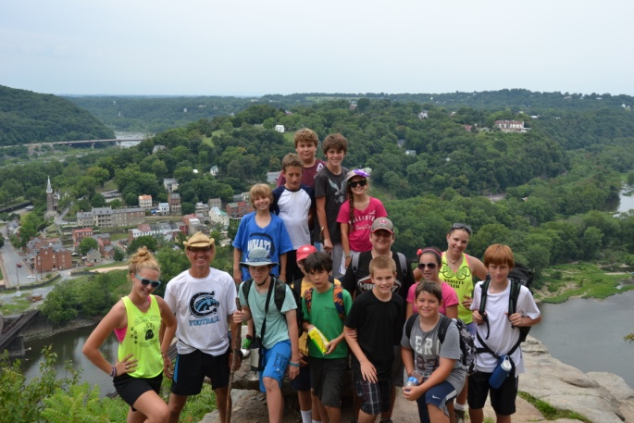
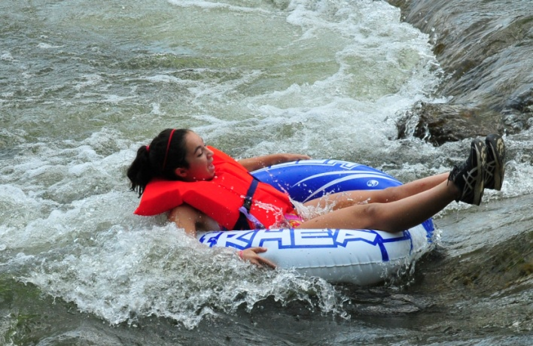
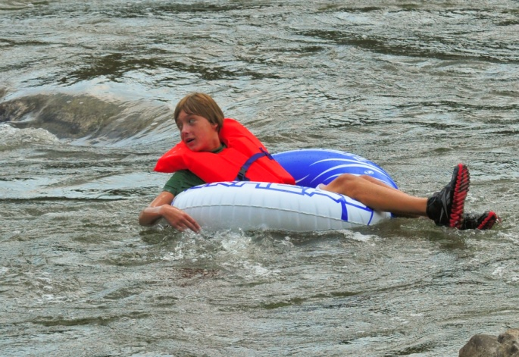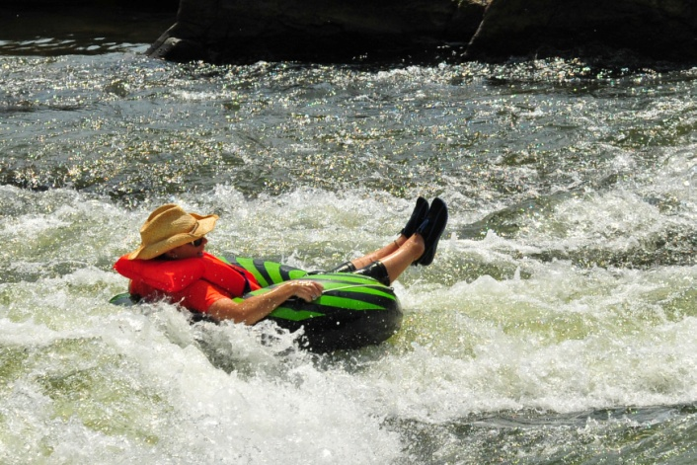
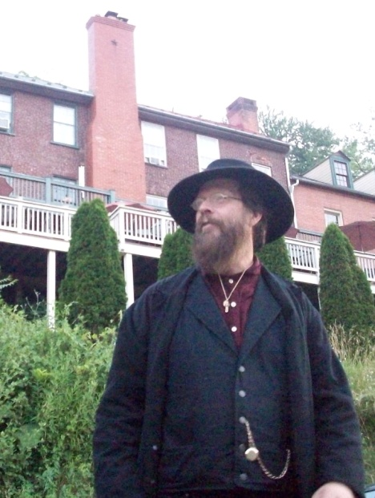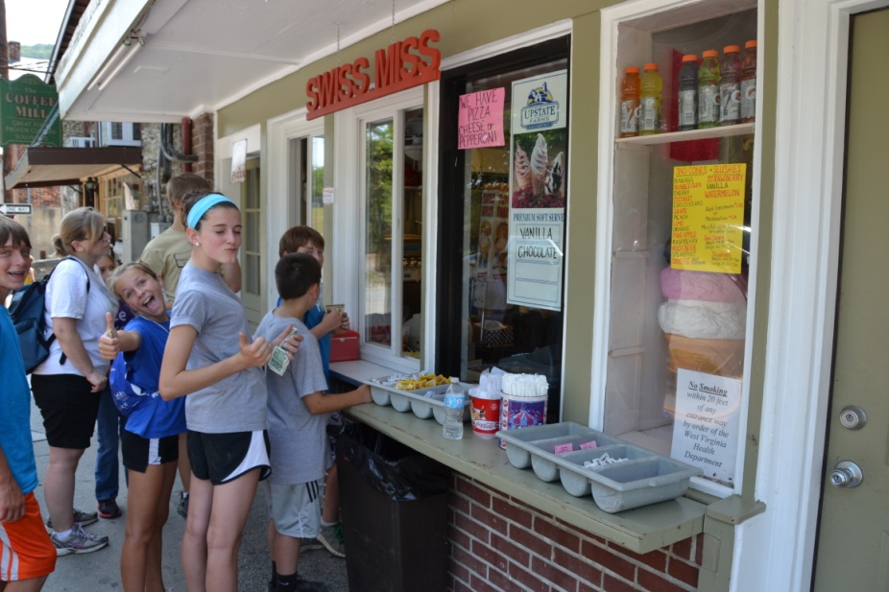
Ghost tour guide Last Stop: Harpers Ferry Ice Cream!

