“Wet 'N Wild Water Week 1”
June 24-28, 2019
Meet every day at the Emmorton Rec. Center. The bus will be waiting for you. From there, we’ll travel daily to different locations throughout the area. We’ll learn about the most amazing substance in the universe—water. We’ll monitor life found in local streams, play with a water balloon sling-shot, tube and snorkel the Potomac River, crab in the Chesapeake Bay, and go to the famous Guppy Gulch Water Park. You’ll want to prepare for our Wet `n’ Wild Water War and Beach Party (Hammerman-style). The first day we’ll be taking a day trip to gorgeous Killgore Falls/Falling Branch. It only gets better from there. Read the letter/itinerary below to see how to prepare each day.
Dear Wet ‘n’ Wild Water Week Camper,
We will be getting wet and swimming every day. We will need to read and sign off on our Swim Safety Plan. If your child isn’t a swimmer, we have personal floatation devices they can wear if it’s ever over their heads. We also have snorkeling gear, but many kids like to have their own (less than $20 at WalMart or Target, or try this link.)
Reminder to all parents, for an extra $50, Mr. Pritchard will include a ride home from camp, if 3:30 is inconvenient in your work day.
**If you think you are up to it, parents are welcome to attend any day, but you may need to drive yourself, if the bus is full. On Wednesday, you’ll pay a $22 (adults), or $30 (siblings over 9 years old) fee for Guppy Gulch.

Scroll down for a Printer-friendly packing list and itinerary. Just print page 2.

Questions? Call 443-243-9440 or email me at ecotechsummercamp@hotmail.com
Register Now!

Wet ‘n’ Wild Water Week 1 Itinerary
There are a few things you need to bring to camp every day. They are listed below:
- A day pack (like a school book bag)
- A bagged lunch
- At least 1 liter of water
- A plastic bag of dry clothes (just in case you want to change)
- A towel
- Closed-toed shoes for water (old tennis shoes work best.)
- Sunscreen
- bug repellant
- A hat
- Optional binoculars

Look at the chart below for a list of activities and special daily items to pack in addition to the ones listed above. Start saving gallon jugs, and find the biggest squirt gun you can for the Wet ‘n’ Wild Water War!
Day | Activity | Location | What to bring
Monday  6/24/19  8:30 – 3:30 | Introductory games, watershed hike, stream explore,  Water challenges | Deer Creek at Sandy Hook and Falling Branch Park | Just what’s listed above, goggles if you have them.
Tuesday  6/25/19  8:30 – 3:30 | Wet ‘n’ Wild Water War and beach party, Stand-up Paddleboards/ kayaks, Keep away in the bay, water-balloon sling shot | Hammerman Area of Gun Powder State Park, Middle River | Lunch and water, Water Guns, empty gallon jugs, money for snack bar(if it’s open), beach stuff (Frisbees, sunscreen, footballs, rafts, towel, etc.)
Wednesday  6/26/19  8:30 – 3:30 | Water park (The Blob, trampoline, beach, mountain, etc.) Wow! | Guppy Gulch, Delta, PA | Beach stuff, money for snack bar, bravery for the Blob! , goggles if you have them.
Thursday  6/27/19  8:30 – 3:30 | Tubing and snorkeling | Harpers Ferry, West Virginia or, if possible, Gun Powder River | Bring your snorkel and mask. Put your small towel and lunch in a zip-loc bag. Pack light. We’re tubing.
Friday  6/28/19  8:30 – 3:30 | Crabbing from the dock, crab dissection | Sandy Point State Park | Just what’s listed above, any crabbing stuff you may own
Can’t wait to meet you!

Scroll down for a picture gallery.

Fun at Falling Branch
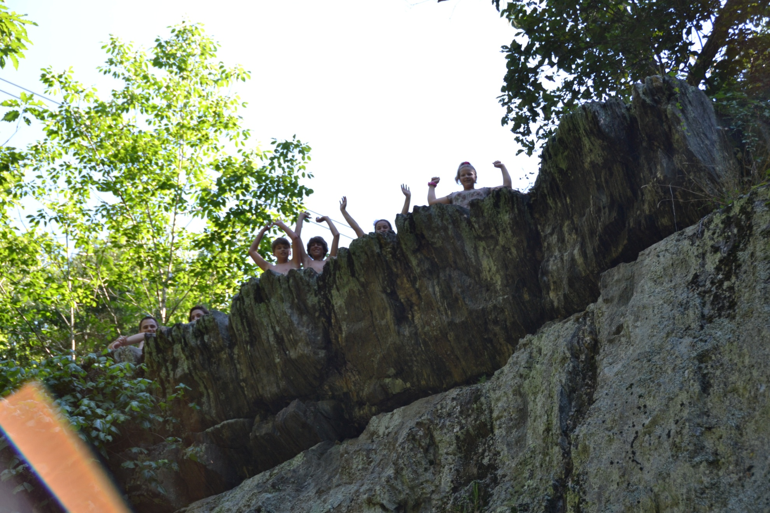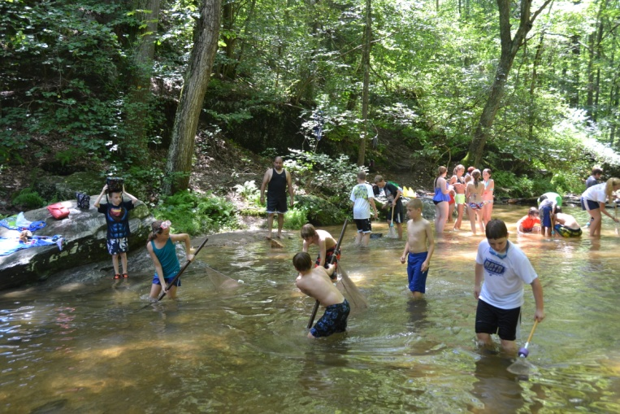
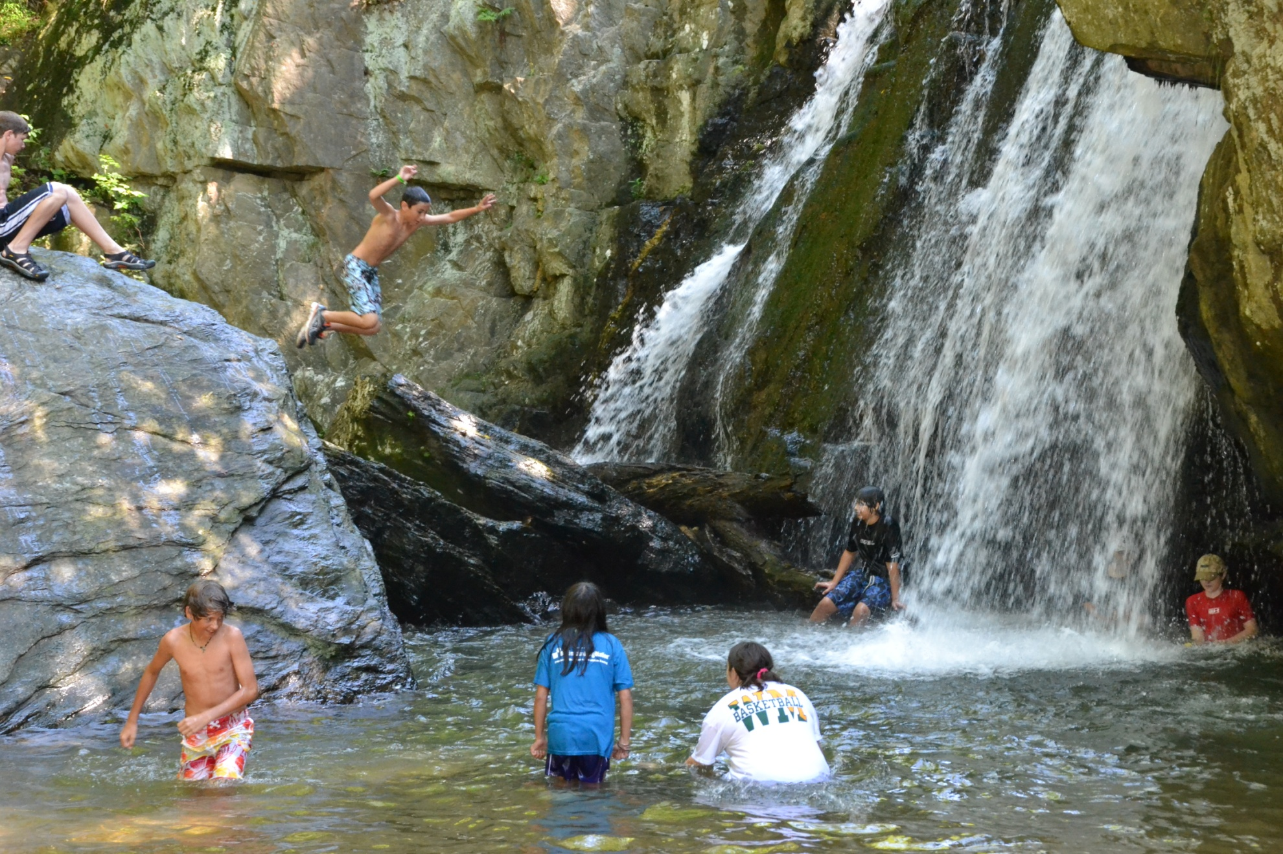
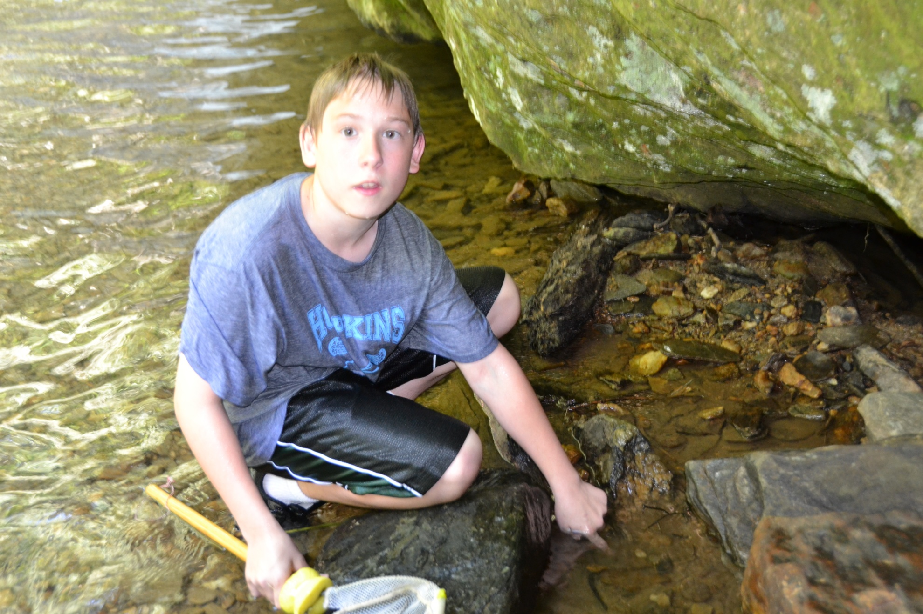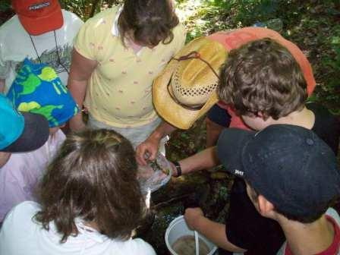

and at Hammerman Beach, Gun Powder St. Park
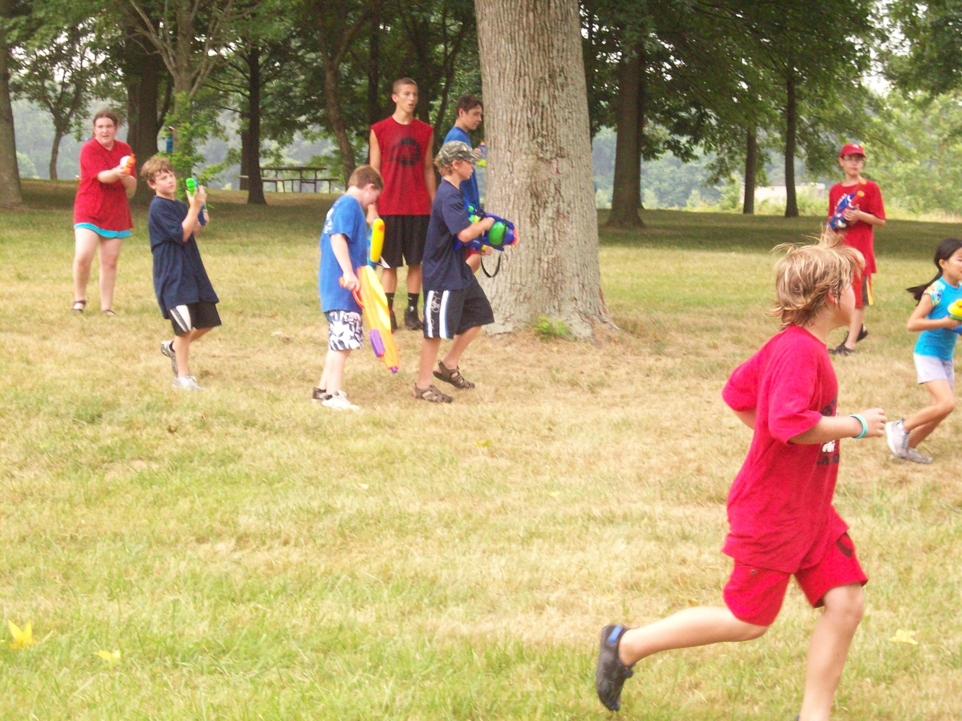Cra 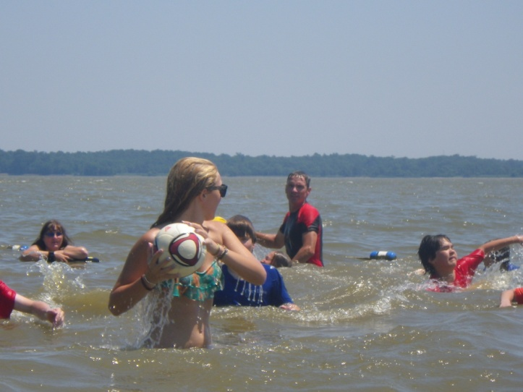
Crabbing at Sandy Point State Park

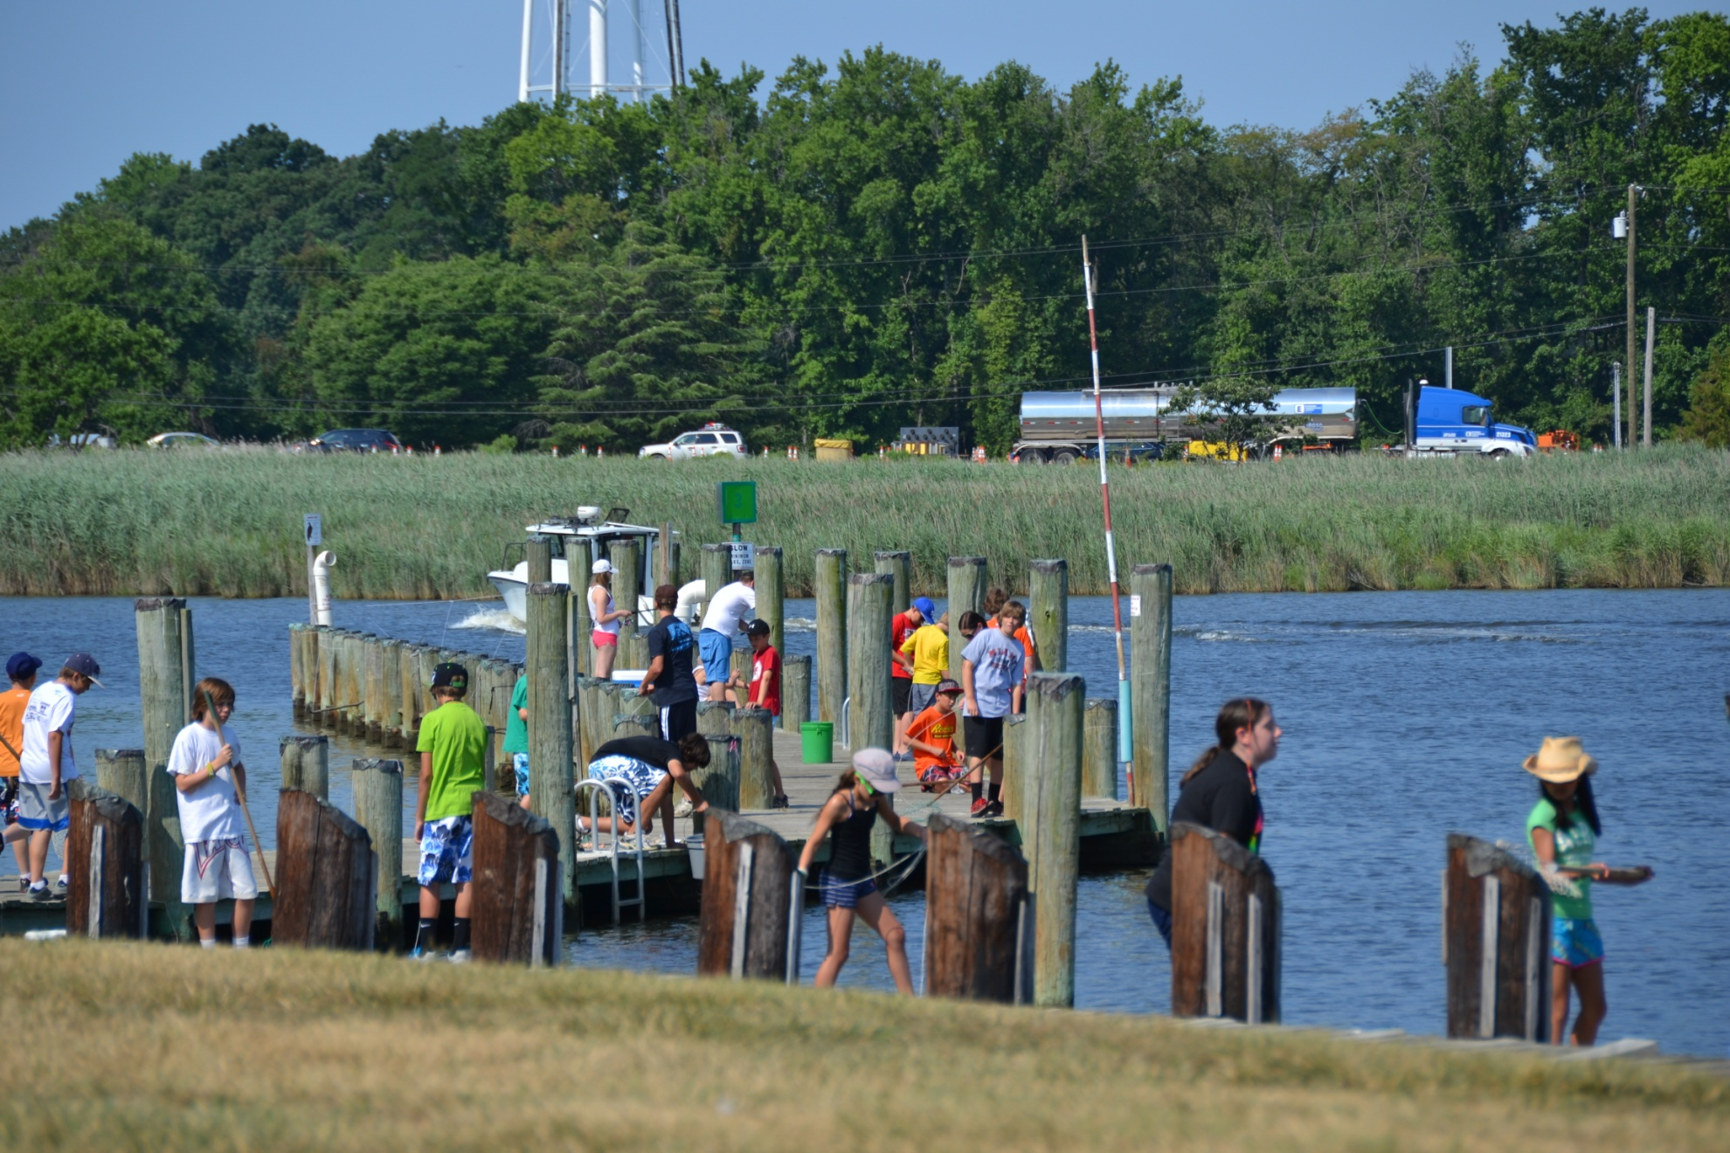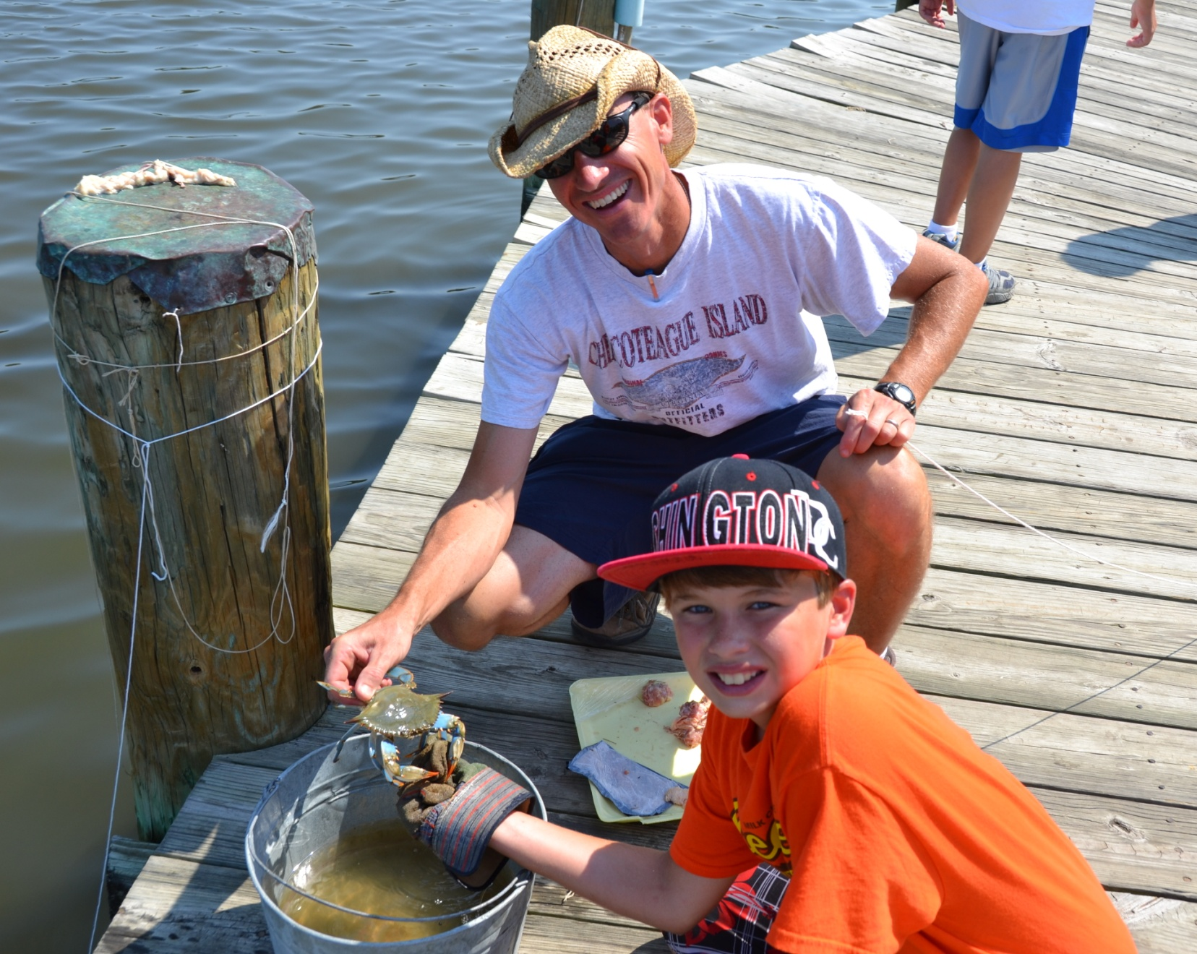
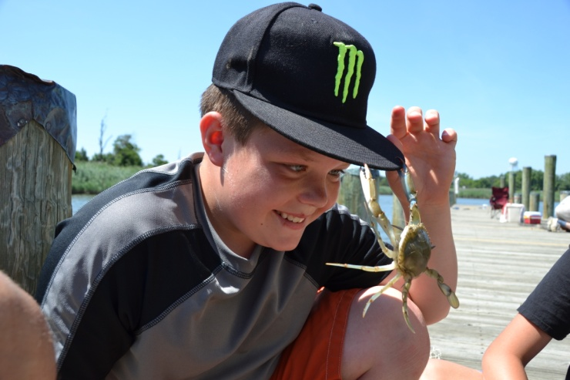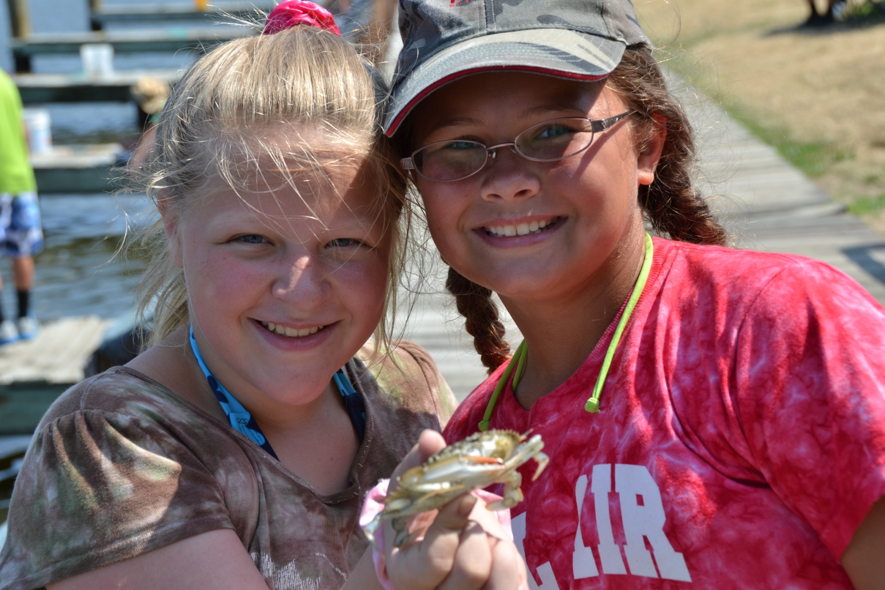
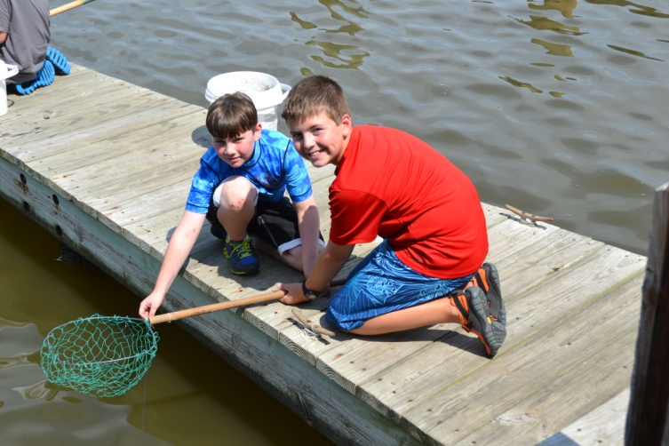

Tubing and snorkeling in the crystal clear Gun Powder River

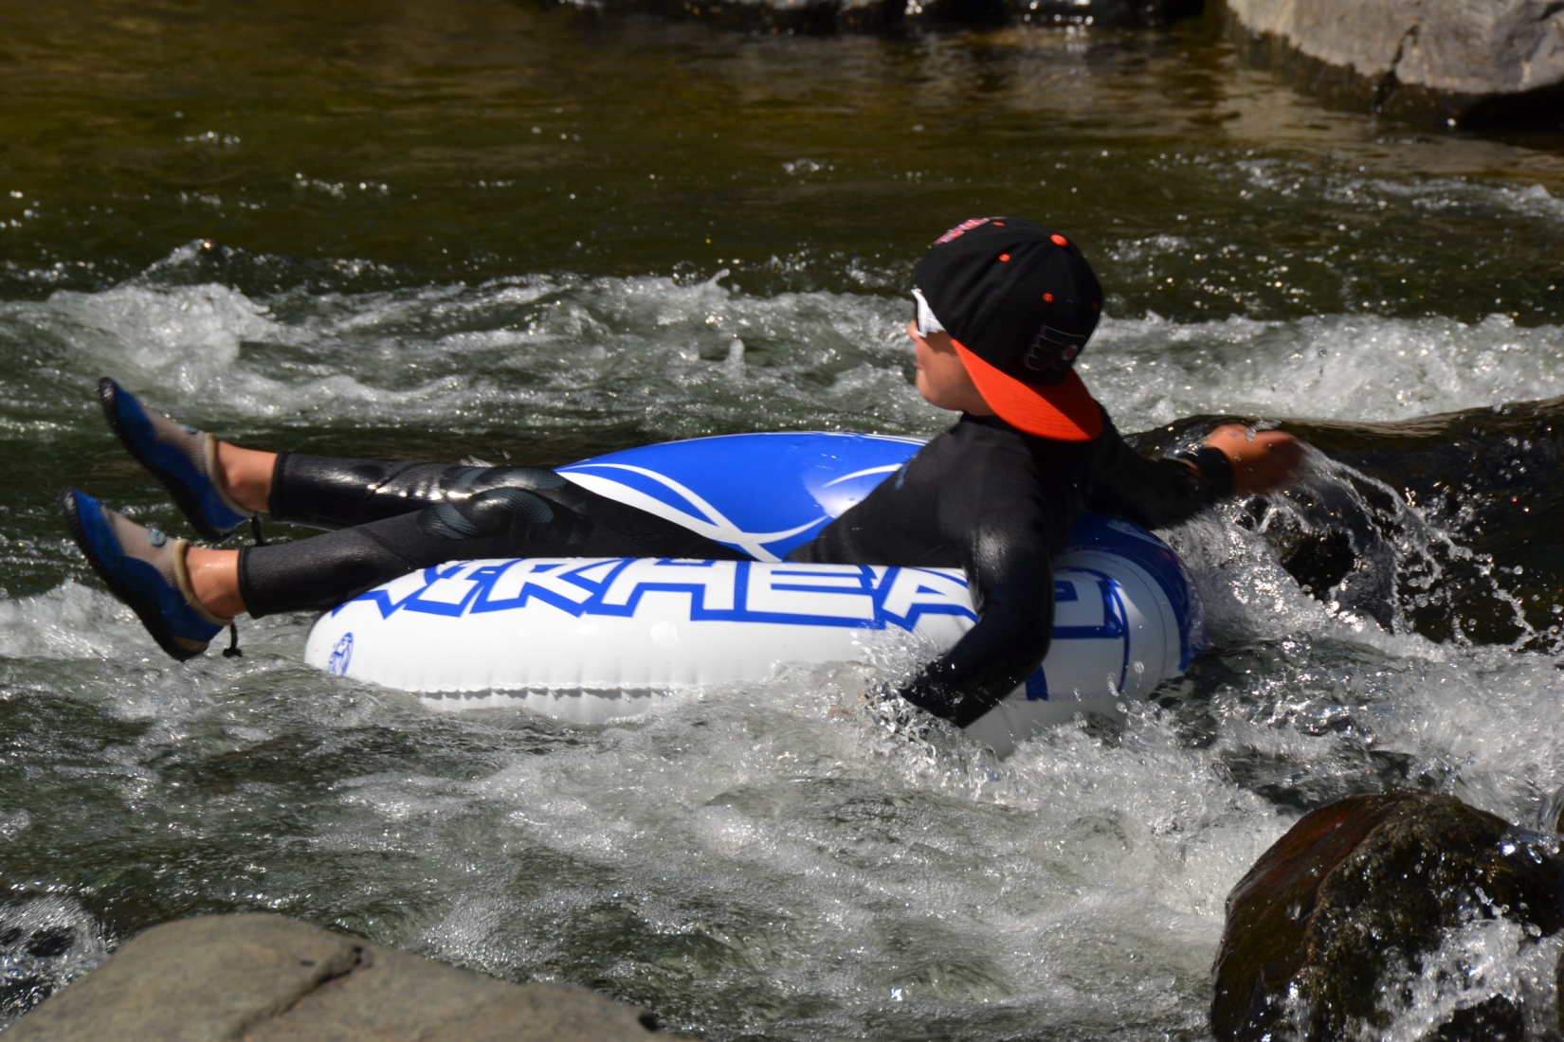
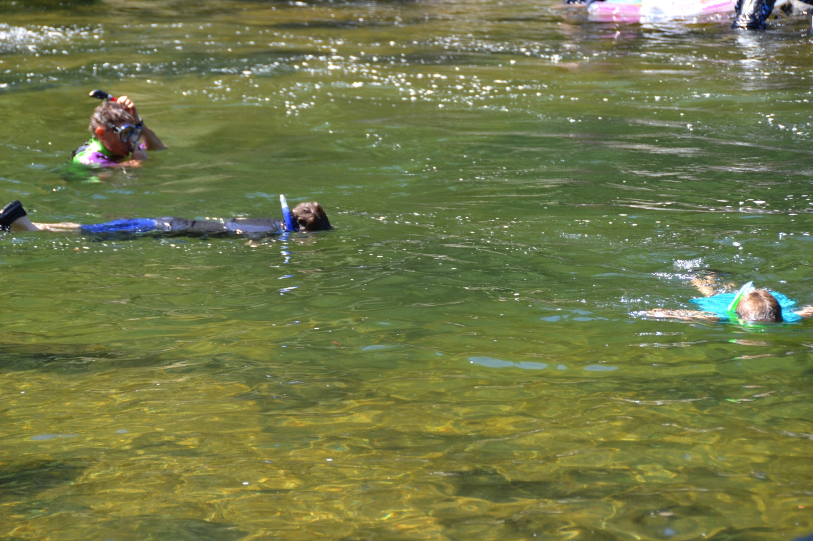

…and you can’t forget Guppy Gulch Water Park!!!

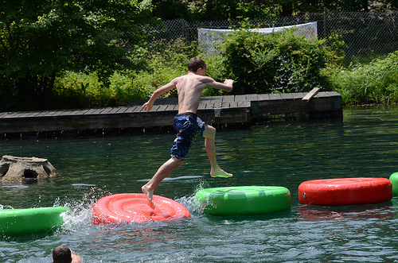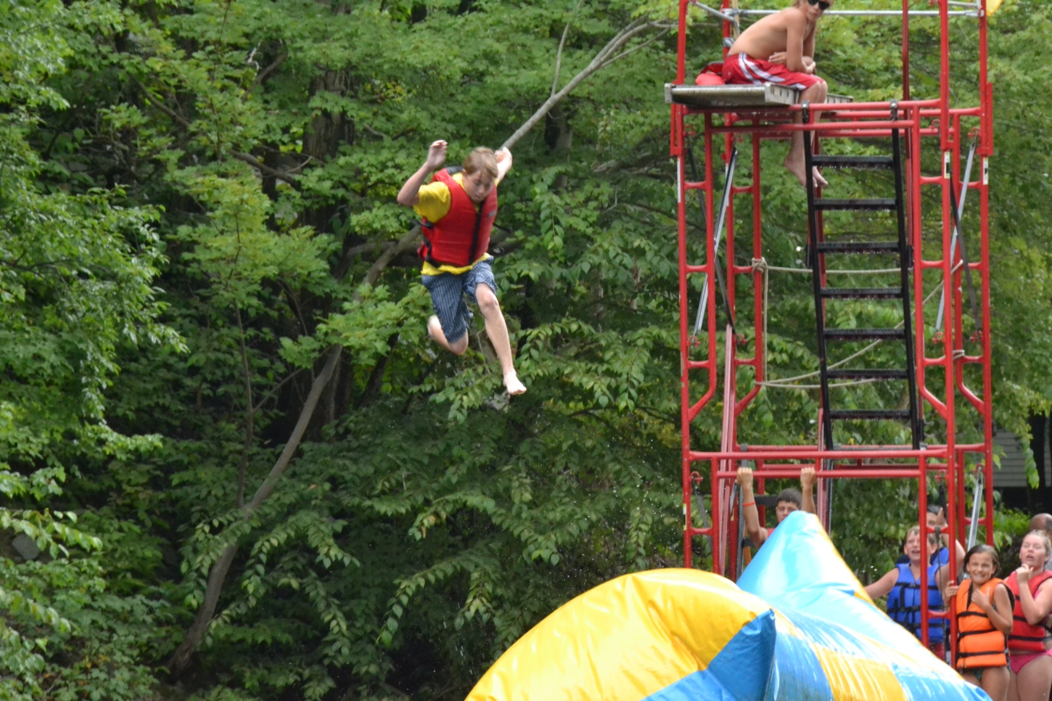
The Blob, if you dare!!!

