The Experience 2
August 14-18, 2017
Registration: $370.00
Dear Experience Camper,
Are you ready for the best week of your summer? Well, if you’re not, this letter will help you to get ready!
There are a few things you need to bring to camp every day, when you come at 8:30. They are listed below:
- A day pack (like a school book bag)
- A bagged lunch
- At least 1 liter of water
- A plastic bag of dry clothes (just in case you want to change)
- A towel
- Closed-toed shoes for water (old tennis shoes work best.)
- Sunscreen and bug repellant
- A hat
- Optional binoculars

Look at the chart below for a list of activities and special daily items to pack in addition to the ones listed above. Every day, show up at Emmorton Rec Center to catch the ride to our adventure destination of the day.

Parents are welcome to attend for free any day, unless fees apply. You may need to drive, if our transportation is full.

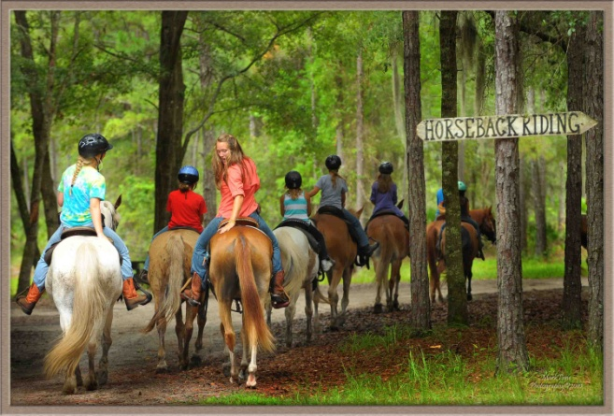
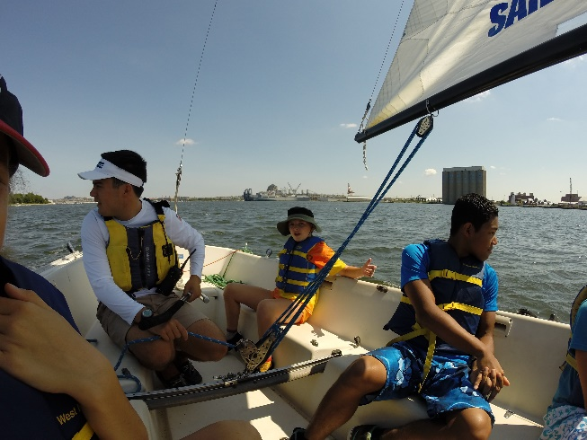
Itinerary
Sailing lessons
Day | Activity | Location | What to bring
Monday  8/14  8:30-3:30 | See spectacular scenery of the Great falls of the Potomac River, Hike the Billy Goat Trail, see the historic C&O canal/boat | Great Falls National Historic Park | Sturdy hiking shoes, couple pairs of socks, lots of water + normal list.
Tuesday  8/15  8:30-3:30 | Horse-back riding lesson, trail ride and some stream exploration | Rolling Hills Riding Academy, Port Deposit, MD | Just what’s on the list + if you have boots with a heel on them, that would be best in the stirrups
Wednesday  8/16  8:30 – 3:30 | Learn how to sail right in the Inner Harbor | Downtown Sailing Center | Sunscreen for sure along with the normal stuff
Thursday  8/17  8:30 – 3:30 | Spelunk Dam #4 Cave. C & O Canal Tow Path | Dam #4 Cave  on the C & O Canal Towpath | Everything listed plus your bike-helmet, flashlight and extra batteries. Wear clothes that can get muddy.
Friday  8/18  8:30 - 3:30 | Water park (Blob, lilly pads, trampoline, 19 – foot tall mountain | Guppy Gulch | Sunscreen, water gun, colors and beach stuff
Scroll down for some pictures of the activities we’ll be doing this week.

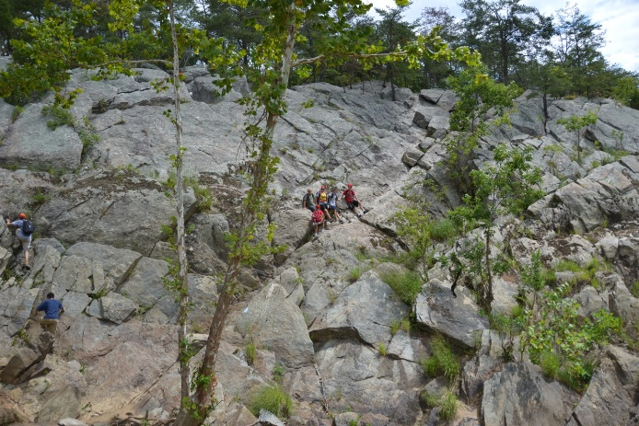
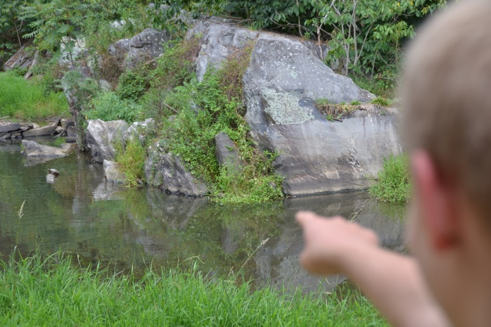
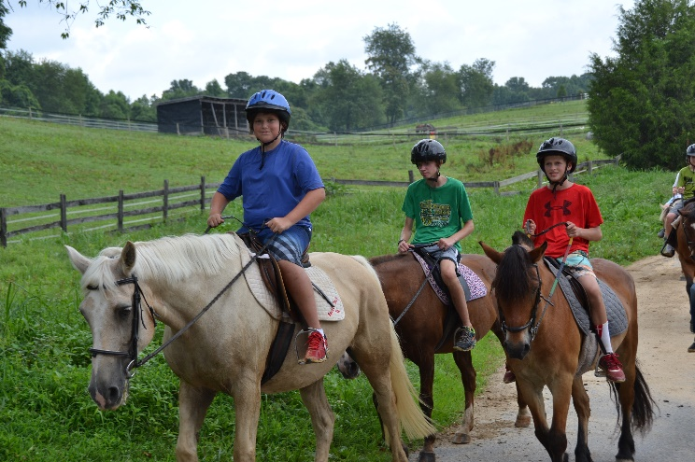
Here’s a week designed to give your kid a safe but adventurous experience they won’t soon forget. Last year, a favorite activity was sailing from the Inner Harbor to Fort McHenry with Downtown Sailing Center. Horse-back riding on the trails of Cecil County with Rolling Hills Riding Academy is a great way to explore nature. We’ll go spelunking in Dam #4 Cave along the C & O Canal Tow Path and take an amazing hike on the Billy Goat Trail at Great Falls National Historic Park. Finally, we finish by partying it up at Guppy Gulch Water Park! It was a huge hit last year…Guppy Gulch is the most fun a kid can legally have. Register Now!
Billy Goat Trail at Great Falls National Historic Park
(Panarama Photo by Smata2 on Flickr)

Caving at Dam#4 Cave
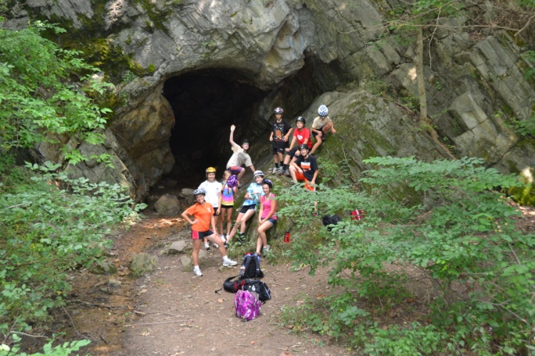
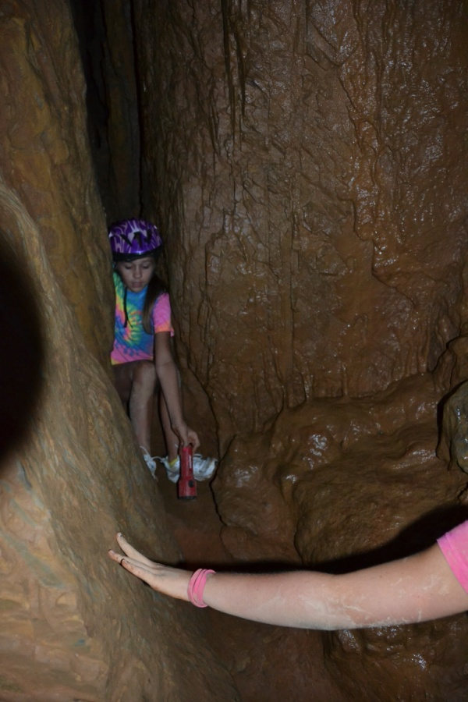
Get up close and personal with a real wild cave. Stalactites, stalagmites and everything! It’s not as claustrophobic as you might think.

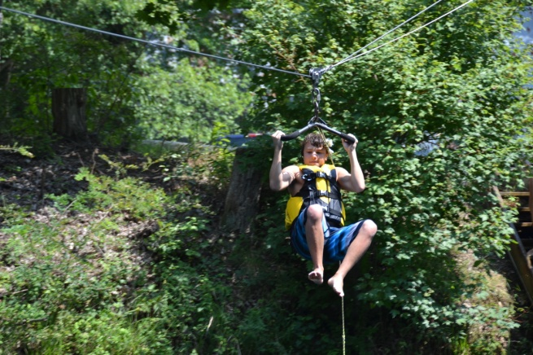
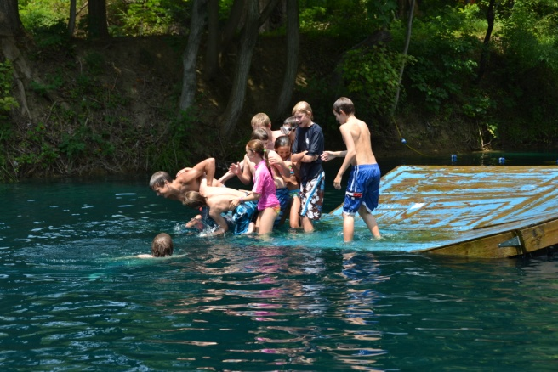
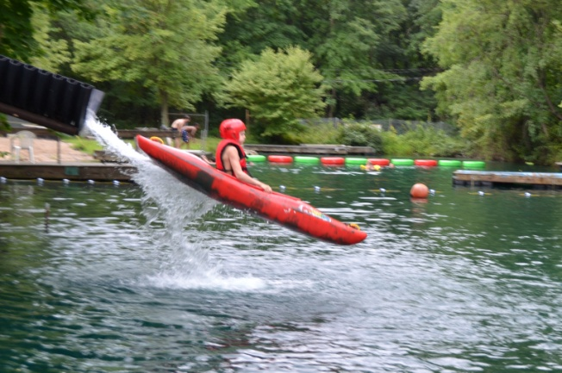
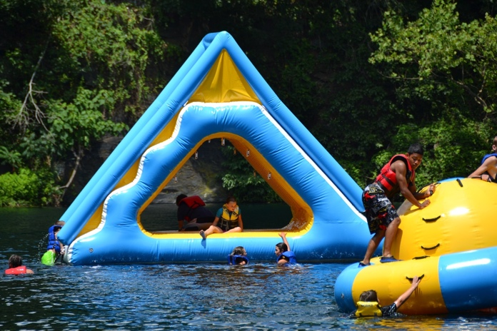
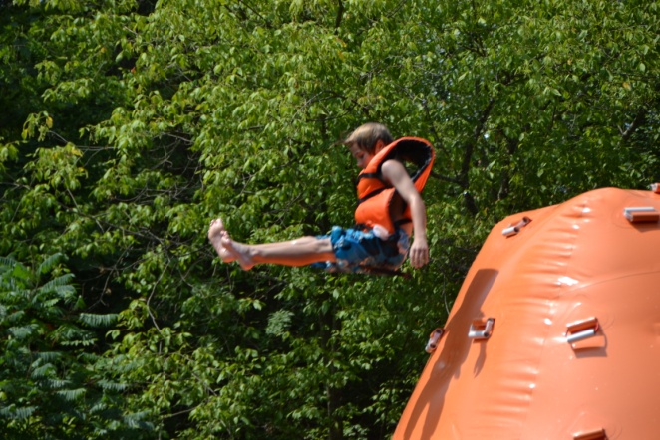
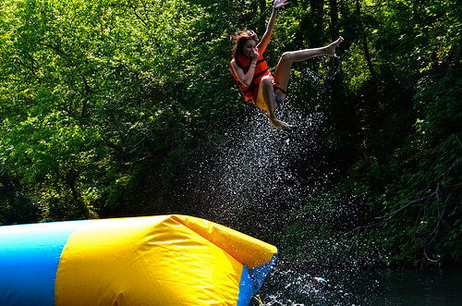
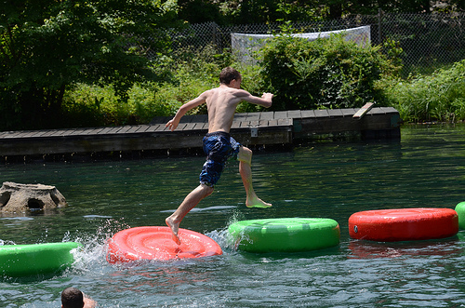
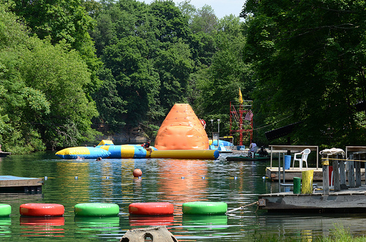
And we must not forget Guppy Gulch Water Park!!!

