Best of EcoTech 2
August 21-25, 2017
Dear Best of EcoTech Camper,
I was challenged to come up with a week that would be better than the rest. I thought that would be easy, but have you seen the other weeks of EcoTech Summer Camp? Let’s just say you won’t be disappointed this week! When campers were poled, these activities kept coming up. The first was Guppy Gulch, which is understandable, since it’s like they throw a party for us every time we go there. Harpers Ferry overnight is a close second, but we’ll start out at Hammerman Beach in GunPowder State Park, where we will do the Wet ‘n’ Wild Water War. We’ll even be hiking the BillyGoat Trail near D.C. Sound awesome or what? Keep scrolling down to see our itinerary.
Registration fee: $550 (aftercare available for an extra $50 fee)

Register Now!

**Parents are welcome to attend, provided we get a 2-week notice to allow for the $50-background check, any day Mon.- Wednesday. You will be charged an extra $22.00 for admission to Guppy Gulch Water Park on Wednesday. The overnight will require an additional $35 to cover food, camping and ghost tour admission. You won’t be permitted to attend any day without the background check
There are a few things you need to bring to camp every day, when you come at 8:30. They are listed below:
- A day pack (like a school book bag)
- A bagged lunch
- At least 1 liter of water
- A plastic bag of dry clothes (just in case you want to change)
- A towel
- Closed-toed shoes for water (old tennis shoes work best.)
- Sunscreen and bug repellant
- A hat
Look at the chart below for a list of activities, and special daily items to pack in addition to the ones listed above. Every day, we are dropped off and picked up at the Emmorton Rec Center. Someone will be there from 8:00a.m., but program begins at 8:30. From there, we will take a bus to the following destinations. Pick-up at same spot at 3:30. Rides home can be pre-arranged for $50/week, provided distance doesn’t exceed tolerance levels.
Overnight packing list

Packed Lunch for Thurs.
Comfortable hiking shoes
Water shoes for the river
Bathing suit w/ plastic bag for storage
Sunscreen
Hat, sun glasses
3-4 pairs of socks (not no-show socks)
Clothes to change into Fri. in its own bag
Sleeping bag/pillow
Toiletries and towel
Day Pack (to carry separate from clothes bag)
2 refillable water bottles
Flash light
Rain jacket
Cards or similar non-electronic games/ balls
Money for Harpers Ferry ($20 is sufficient)
Snacks
Binoculars and/or camera

Don’t bring electronics, knives or lighters

Day | Activity | Location | What to bring
Monday  8/21  8:30- 3:30 | Introductory games, Wet ‘n’ Wild Water War, beach time | Hammerman Beach | Just what’s listed above plus beach stuff, Super Soaker or other long distance squirt gun, empty jugs
Tuesday  8/22  8:30- 3:30 | See spectacular scenery of the Great falls of the Potomac River, Hike the Billy Goat Trail, see the historic C&O canal/boat | Great Falls National Historic Park | Sturdy hiking shoes, couple pairs of socks, lots of water + normal list.
Wednesday  8/23  8:30- 3:30 | Water park (Blob, lilly pads, trampoline, 19 – foot tall mountain | Guppy Gulch, Delta, PA | Sunscreen, snorkel and money for snack bar and activities ($10 is plenty.)
Thursday  8/24  8:30, overnight to … | Tube the Potomac River, dinner at Hostel, hike into town for Harpers Ferry Ghost Tour, night hike, s’mores... | Meet bus at Emmorton Rec. Center and drive to Harpers FerryHostel  19123 Sandy Hook Road, Knoxville, Maryland 21758  (301) 834-7652 | See packing list for Harpers Ferry Overnight (below)
Friday  8/25  3:30 (pick-up) | Hike the Maryland Heights Trail and do the historic town of Harpers Ferry. | We’ll return to the rec. center by 3:30 for pick-up. | Stamina and some money for ice cream!

Scroll down for pictures of the activities we have planned for you.
Photo Gallery
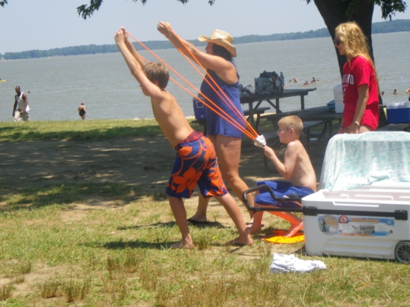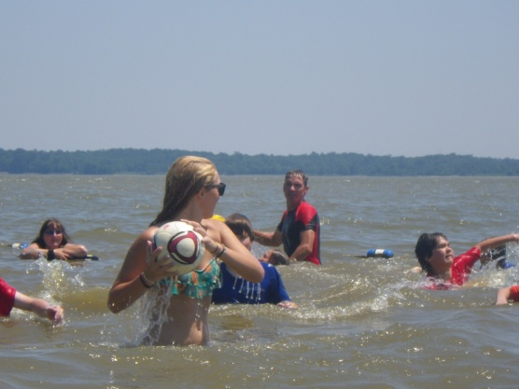
Hammerman Beach at Gun Powder River

Great Falls/ Billy Goat trail
Guppy Gulch
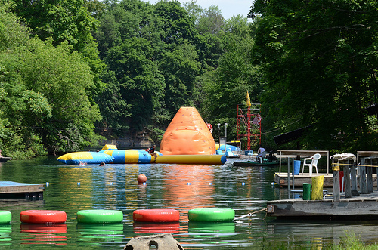
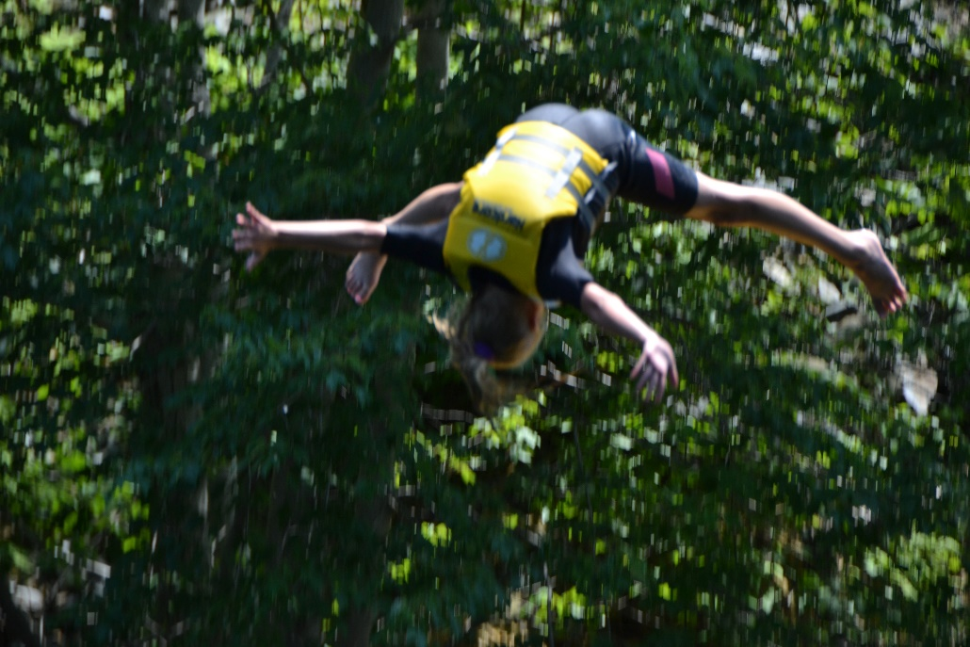

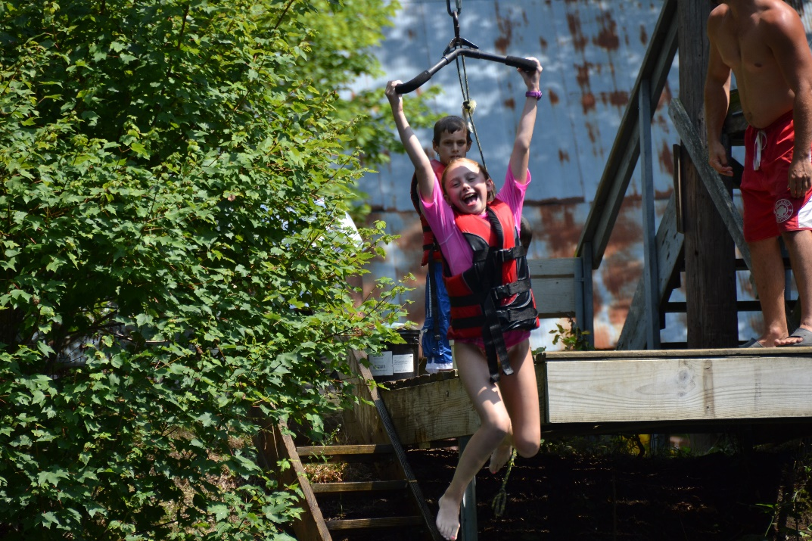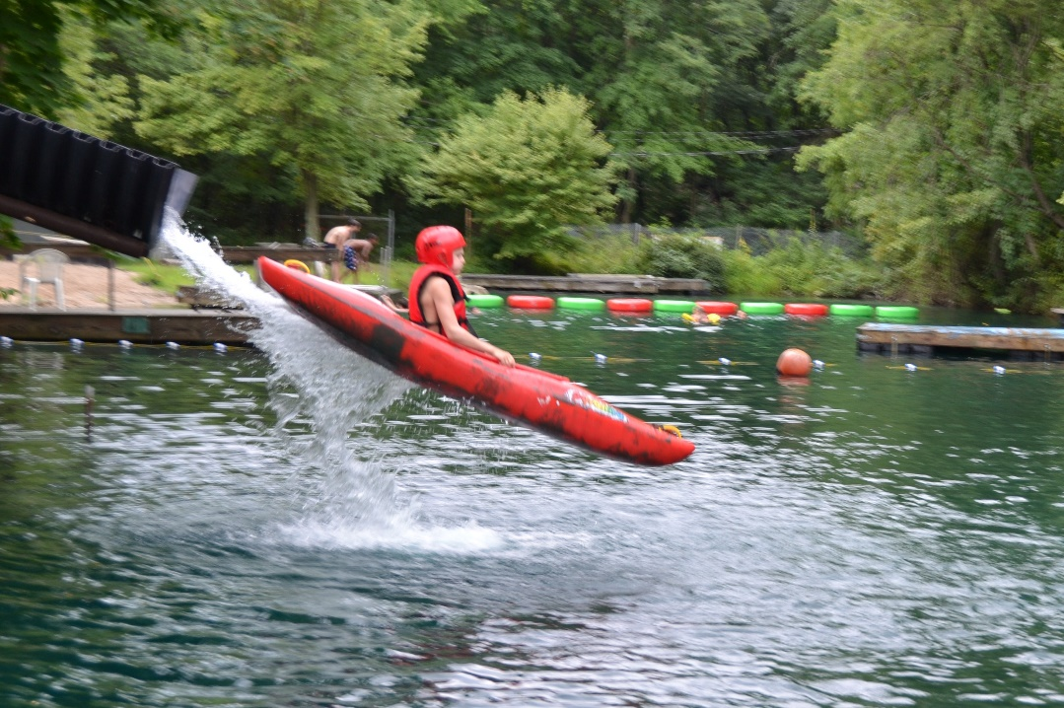
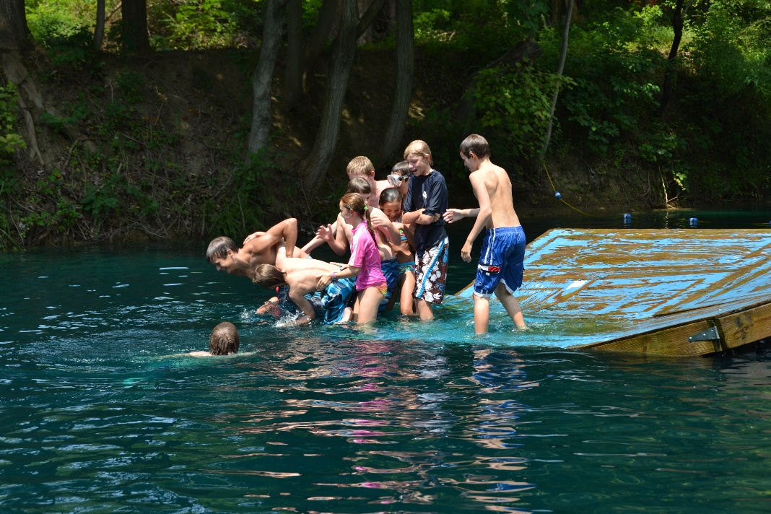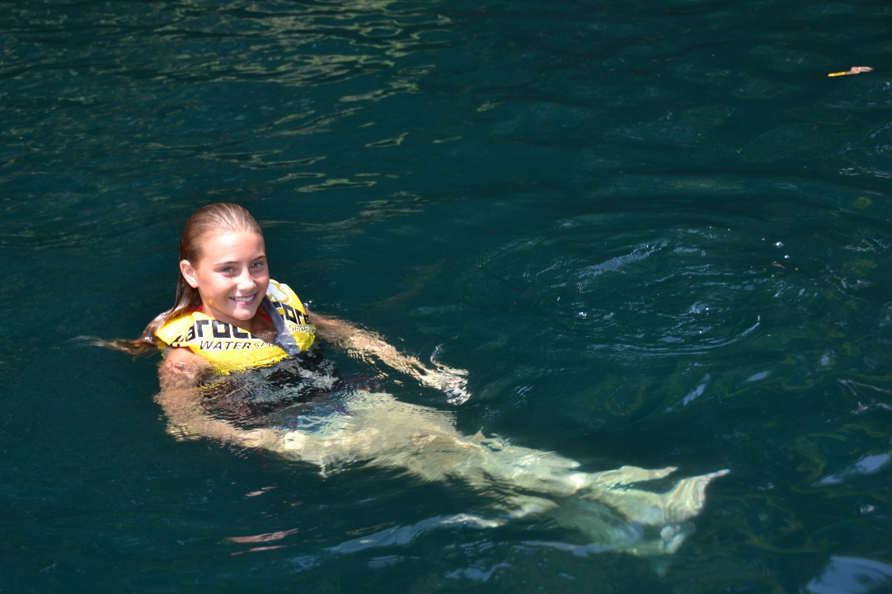
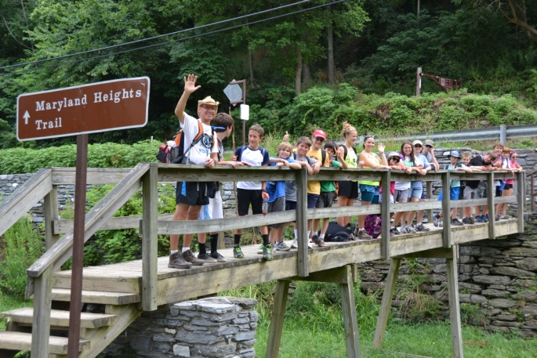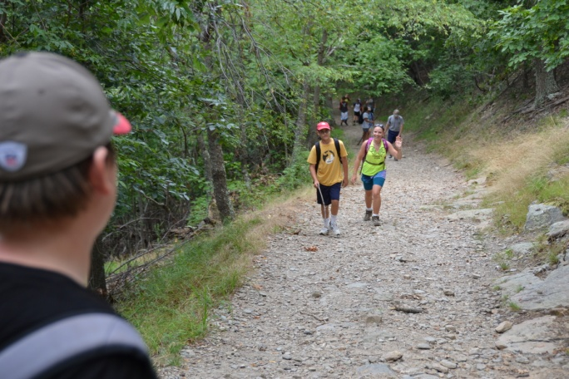
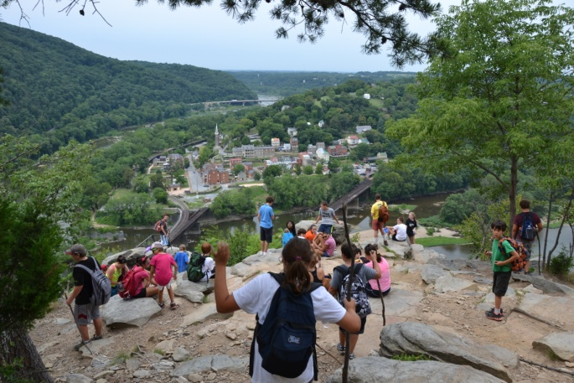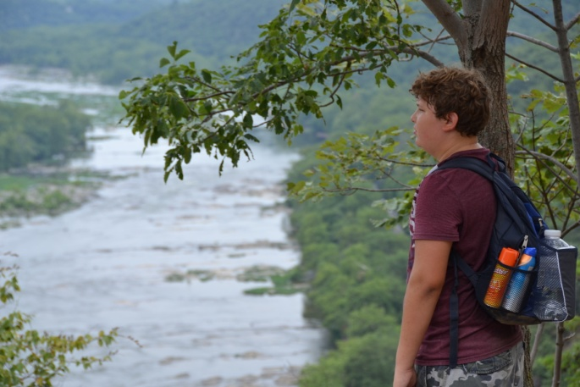
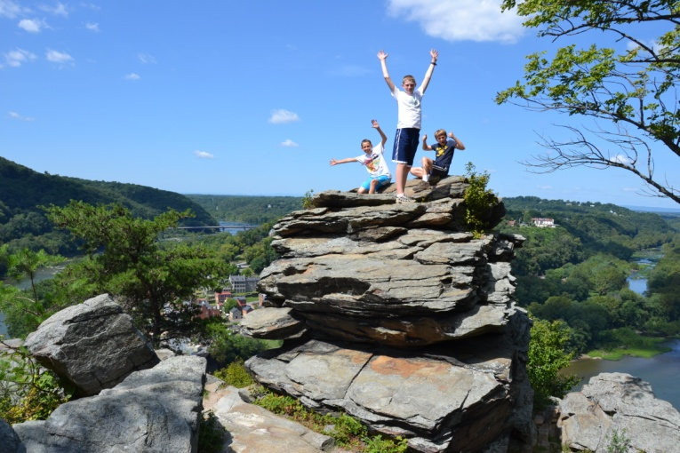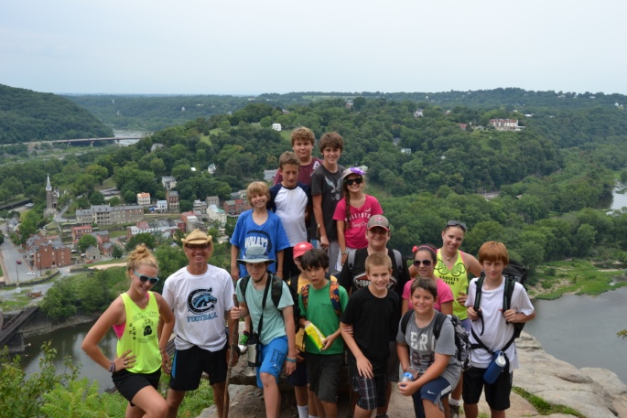
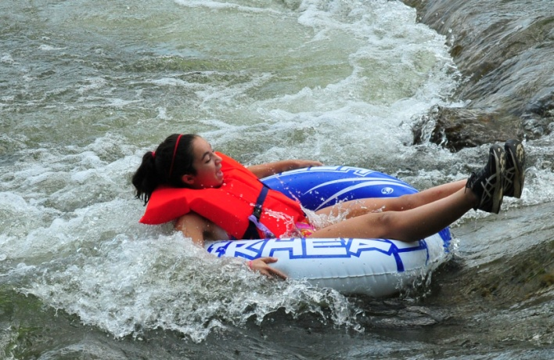
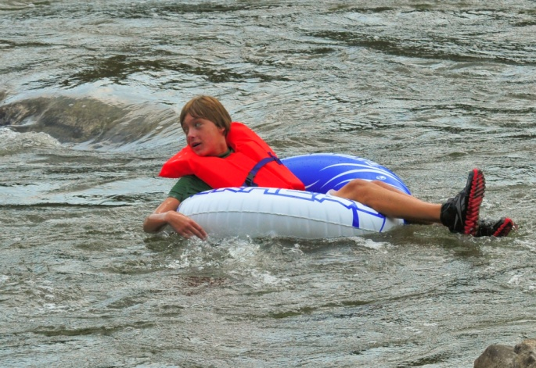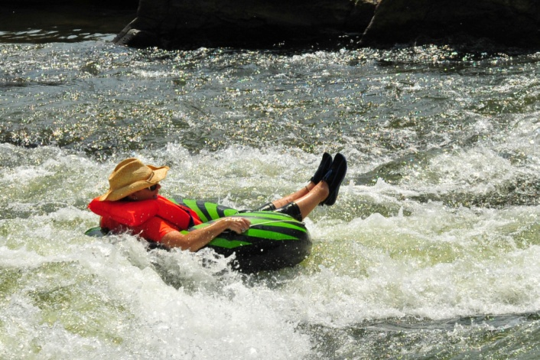
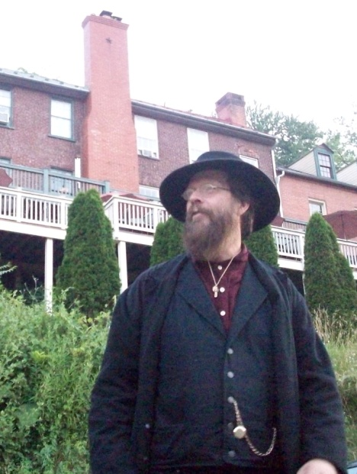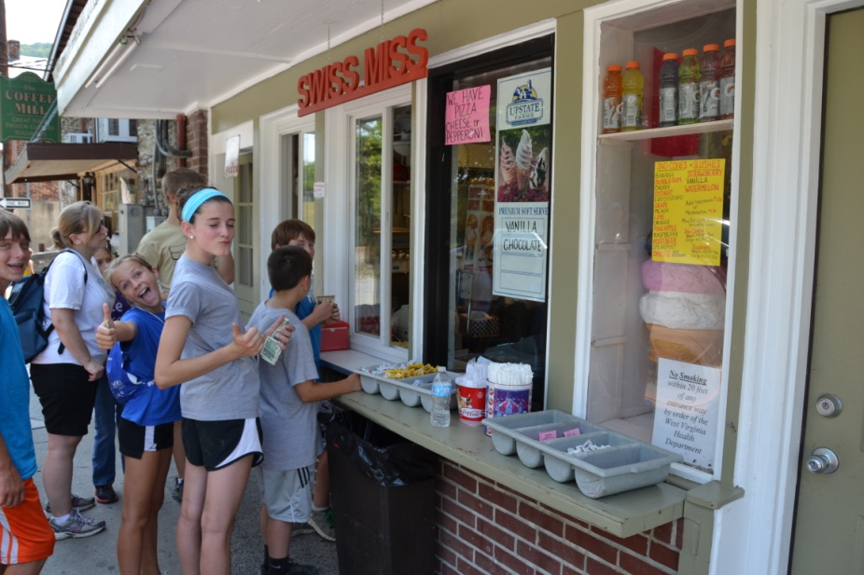
Ghost tour guide Last Stop: Harpers Ferry Ice Cream!

